Assignment 5.3
Problem Statement 1:-
Find the list of players that have been selected in the qualifying round (DEFENCE>55).
Solution:-
Pokemon_Data = LOAD ‘/home/acadgild/hadoop/Pokémon.csv’ USING PigStorage(‘,’) AS(Sno:int,Name:chararray,Type1:chararray,Type2:chararray,Total:int,HP:int,Attack:int,Defense:int,SpAtk:int,SpDef:int,Speed:int);
DUMP Pokemon_Data;
list_Defense_more_55 = FILTER Pokemon_Data BY Defense>55;
dump list_Defense_more_55;

Problem Statement 2:-
State the number of players taking part in the competition after getting selected in the qualifying round.
Solution:-
group_Defense = Group list_Defense_more_55 All;
count_Defense = foreach group_Defense GENERATE COUNT(list_Defense_more_55);
dump count_Defense;
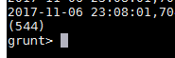

Problem Statement 3:-
Using random() generate random numbers for each Pokémon on the selected list.
Solution:-
random_list = foreach list_Defense_more_55 GENERATE RANDOM(),Name,Type1,Type2,Total,HP,Attack,Defense,SpAtk,SpDef,Speed;
dump random_list;
Problem Statement 4:-
Arrange the new list in a descending order according to a column randomly.
Solution:-
random_list_desending = ORDER random_list BY $0 DESC;
dump random_list_desending;
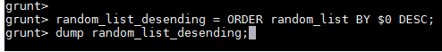

Problem Statement 5:-
Now on a new relation again associate random numbers for each Pokémon and arrange in descending order according to column random.
Solution:-
random_list2 = foreach list_Defense_more_55 GENERATE RANDOM(),Name,Type1,Type2,Total,HP,Attack,Defense,SpAtk,SpDef,Speed;
random_list2_desending = ORDER random_list2 BY $0 DESC;
dump random_list2_desending;

Problem Statement 6:-
From the two different descending lists of random Pokémons, select the top 5 Pokémons for 2 different players.
Solution:-
limit_data_random_list_desending = LIMIT random_list_desending 5 ;
dump limit_data_random_list_desending;
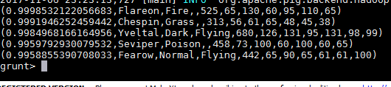
limit_data_random_list2_desending = LIMIT random_list2_desending 5 ;
dump limit_data_random_list2_desending;
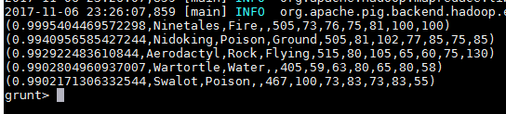

Problem Statement 6:-
Store the data on a local drive to announce for the final match. By the name player1 and player2 (only show the NAME and HP).
Solution:-
filter_only_name1 = foreach limit_data_random_list_desending Generate ($1,HP);
dump filter_only_name1;
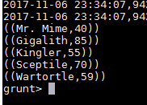
filter_only_name2 = foreach limit_data_random_list2_desending Generate ($1,HP);
dump filter_only_name2;

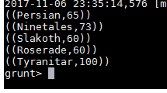
STORE limit_data_random_list_desending INTO ‘/home/acadgild/hadoop/Pokemon_player1.txt’;
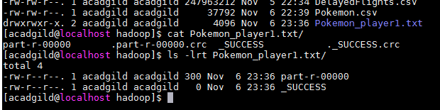
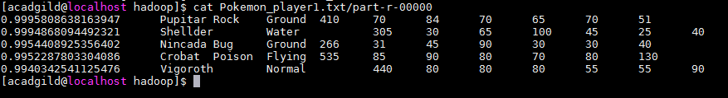
STORE limit_data_random_list2_desending INTO ‘/home/acadgild/hadoop/Pokemon_player2.txt’;
